The last flight of Petr GINZ
The „The last flight of Petr Ginz“ is a documentary. The film has two directors, Sandra Dickson and Churchill Roberts. In the film, we all get to know Petr and what happened to him. By the age of 14 he had written five novels, he was also really talented for painting and drawing. He was interested in the sciences and yearned for knowledge. Because of his parents' interest in Esperanto, Petr also became a fluent speaker of that language. Young Petr was transported to Theresienstadt concentration camp in October 1942. The main characters are Petr and his younger sister. I enjoyed watching the documentary because I think that it is important for students and other people to see all the horrible things Petr had to go through.
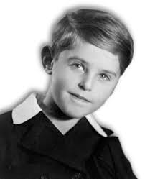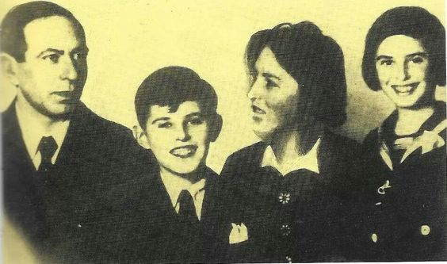

Paola Oltran 8.a

